Ripley Central School District
Ripley, New York
Telephone No. (716)736-2631

TEACHER APPLICATION FORM
Application for Position as Teacher of
Type of New York State Certificate Held
Name

Social Security Number
Permanent Address

Phone Number

City |  | State |  | Zip Code
Grade and Subjects Preferred (in order of Preference
Available Date

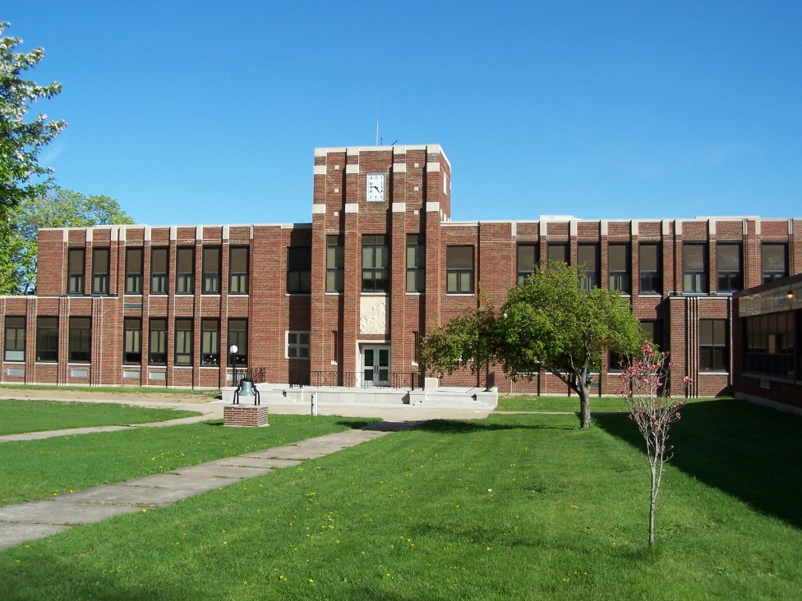

It is the policy of Ripley Central School not to discriminate on the basis of sex in its educational programs, activities or employment policies as required by the Title IX of the 1972 Education Amendments. Inquiries regarding compliance with the Title IX may be directed to the Director of the Office of Civil Rights, Department of Health. Education, and Welfare, Washington, D.C., or the Ripley Central School Title IX Coordinator.

To teach in the Ripley Central School District you need: A New York State teaching certificate for a particular field.
Information on certification available from the Certification Officer, 8685 Erie Road, Angola, New York 14006 (800-228-1184), or by writing to:
Division of Teacher Education and Certification
State Education Department
Albany, New York 12230

Type of Certification Held |  | Field |  | No.
New York State Teachers’ Retirement System No. |  | Rate
Type of out-state certificate held |  | State |  | No.
Military Service
Branch |  | Years |  | Or Draft Status

I. Professional Preparation
 | School or Institute – Name | Course | Diploma or Degree | Year of Graduation | Dates of Attendance | Total Time Spent (yrs.) | Semester Hrs. Credit
High School

College

University

Graduate Work

Special

II. Applicants should submit transcripts if possible or list total number of hours in subject area.
Subject | College or University | Hours
III. Location of Credentials (School Address): _______________________________________________________________________
____________________________________________________________________________________________________________

IV. Circle any of the following which might be of interest to you:
School Plays Soccer Basketball Baseball Softball Wrestling Student Council Tennis Volleyball
Extracurricular Activities: _______________________________________________________________________________________

V. Professional and other work experience. Please include student teaching if done within the last two years.
School Location | Dates | Position Held or Subjects Taught | Reason for Leaving

VI. References. Please list at least three professional references under whom you have taught or who have first-hand knowledge of your character, personality, scholarship, and teaching ability.
Name | Position | Present Address and Phone Number

VII. Two personal references other than relatives.
Name | Address | Phone | Relationship

List in chronological order your experience, awards, athletics, etc., from freshman year in high school or the past ten years.
Use a separate sheet of paper if needed.

Please write a statement of your philosophy on education. Use a separate sheet of paper if needed.

I declare that I have examined this application and to the best of my knowledge and belief, it is true, correct and complete.

___________________________________________ ___________________________________________________________
Date Signature
For Office Use Only  Application Received ____________________  Credentials Requested ____________________  Credentials & References Received ____________________  _____________________  Interview Scheduled _____________________  Action Taken _____________________ | Thank you for completing this application and for your interest in the Ripley Central School District.  Please return to:  Building Principal  Ripley Central School  P.O. Box 688  Ripley, New York 14775-0688

